**AWS 101 Cloudwatch: View API Metrics and Log Event in the AWS Cloudwatch**

*Posted On January 8, 2019*

**To view API Gateway metrics using the CloudWatch console**  
1. Open the CloudWatch console at <https://console.aws.amazon.com/cloudwatch/>  
2. The cloudwatch can be opened in any desired region where the API, EC2, S3, etc resources has to be viewed.  
   
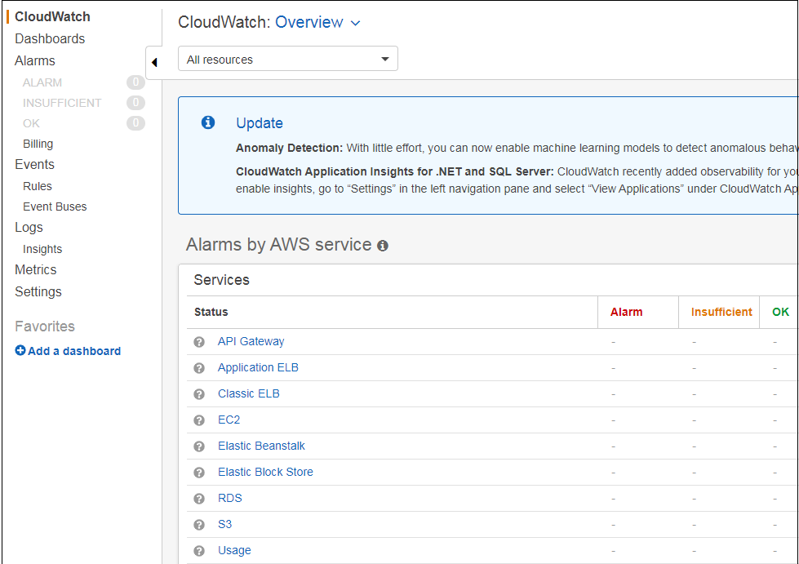  
  
3. In the navigation pane, find Metrics  
4. In the Metrics Categorisation, choose API Gateway among all.  
  
5. Search for the API Gateway by API GatewayName.  
6. View metrics by choice of Stage or API Name  
  
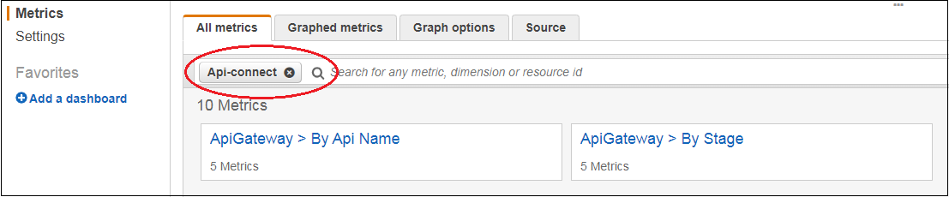  
7. All Metric name would appear for selected stage and API  
  
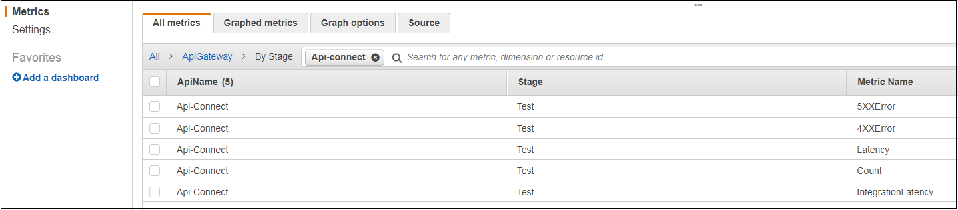

**View API Gateway Log Events in the CloudWatch Console**   
  
1. Open Cloudwatch in Console and view the Log in navigation pane.  
2. It shows various Log Groups  
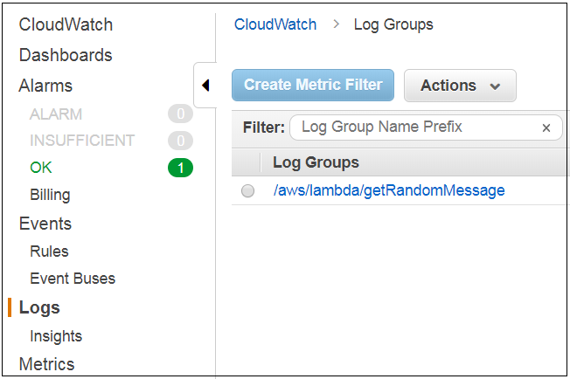  
3. Under Log Group, various Log Stream will appear and it can be filtered by name prefix.   
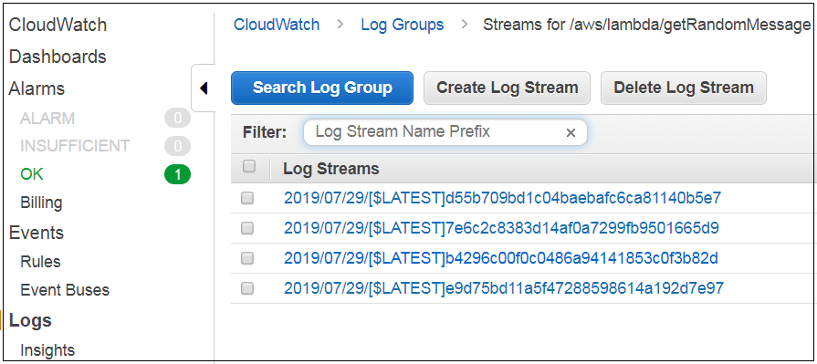  
4. The log stream are listed by Row or Text as per choice of viewing as event row by row or as raw text in the later case.  
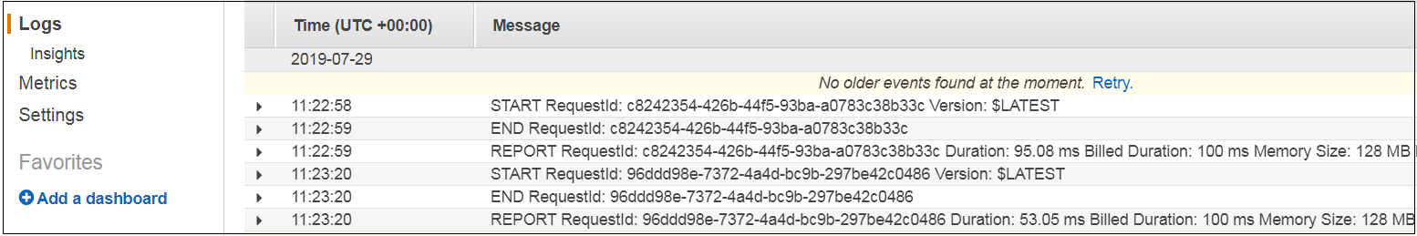  
5. API Gateway creates log groups or log streams for an API stage at the time when it is deployed. The log groups or stream can be manually deleted if required, but it is recommended to let API Gateway manage its deletion as deleting manually may harm API requests and responses.